# Assignment No:7

Practical Exercise: Object Detection using YOLO and Pretrained Model

## 1) Problem Statement

Implement object detection using the YOLO (You Only Look Once) algorithm and a pretrained YOLOv8 model. The model should detect objects in images or video streams and draw bounding boxes with confidence scores around the detected objects.

## 2) Libraries Used

Python:  
1. **OpenCV**: For capturing images and video streams and handling image preprocessing.  
2. **YOLO (ultralytics):** For object detection using a pretrained YOLOv8 model.  
3. **NumPy**: For array manipulation and working with image data.  
4. **Google Colab**: For running the code and displaying images using `cv2_imshow`.

## 3) Theory

YOLO (You Only Look Once) is a popular object detection algorithm that performs object detection in real time by applying a single neural network to the entire image. YOLO divides the image into a grid and predicts bounding boxes and class probabilities for each grid cell.  
  
The YOLOv8 model is a pretrained model that can detect multiple objects in an image or video stream with high accuracy. It uses convolutional layers to learn features from the image and predicts bounding boxes along with confidence scores for each detected object.

## 4) Methods

1. **Loading the YOLO Model**:  
 - The pretrained YOLOv8 model (`yolov8s.pt`) is loaded using the `YOLO` class from the ultralytics library.  
   
2. **Capturing Images**:  
 - The camera is initialized using JavaScript, and images are captured using OpenCV.  
   
3. **Object Detection**:  
 - The captured image is passed to the YOLO model, which detects objects and returns bounding boxes, class labels, and confidence scores.  
   
4. **Drawing Bounding Boxes**:  
 - For each detected object, a bounding box is drawn around it with a label indicating the class name and confidence score.  
   
5. **Displaying the Output**:  
 - The resulting image with bounding boxes is displayed using `cv2_imshow`, and the loop continues until the user presses the 'q' key.

## 5) Advantages and Disadvantages

- **Advantages**:  
 - YOLO is known for its speed and accuracy in real-time object detection.  
 - The pretrained YOLOv8 model can detect multiple objects in a single pass through the image.  
   
- **Disadvantages**:  
 - YOLO requires powerful hardware (e.g., GPUs) for real-time performance, especially for high-resolution images.  
 - The model's performance can be affected by occlusion or poor lighting conditions in the image.

## 6) Diagram

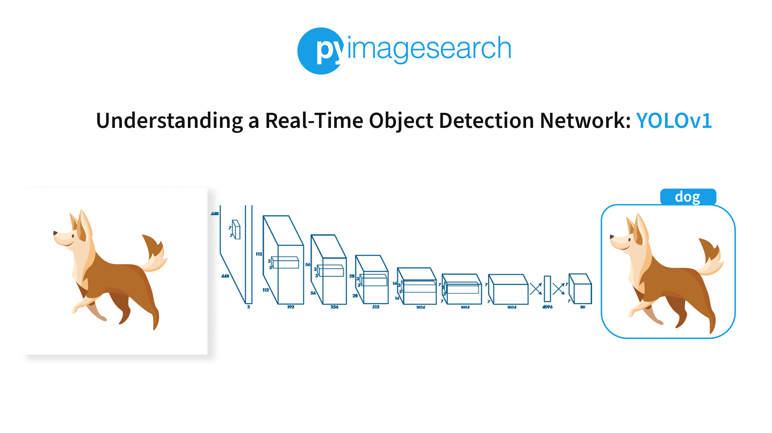

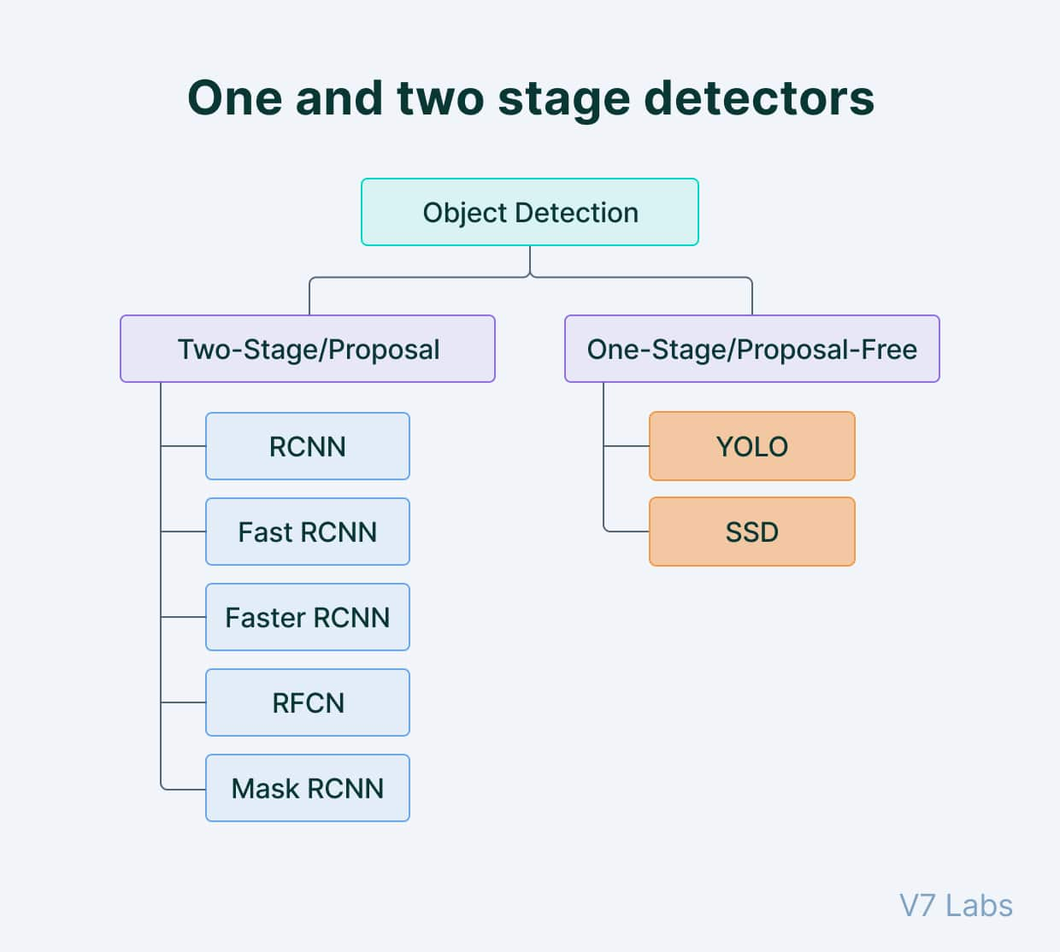

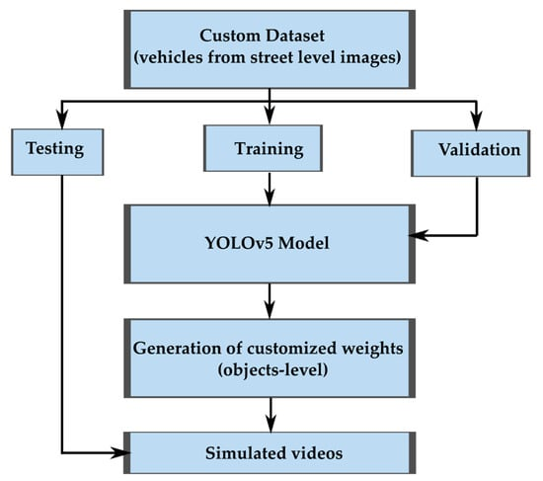

## 7) Conclusion

Object detection using YOLO and pretrained models such as YOLOv8 provides an efficient and accurate way to detect multiple objects in images and video streams in real time. YOLO's single-shot approach makes it one of the fastest object detection algorithms available, and its applications range from autonomous vehicles to security systems and more.